The One With The Rumor

Written by: Shana Goldberg-Meehan
Transcribed by: Eric Aasen
809 谣言
菲比给瑞秋带来了自己的孕妇裤。
莫妮卡邀请了高中同学Will参加感恩节晚餐。Will和罗斯同班，曾是个大胖子，现在减肥后很帅气。
莫妮卡说今年不做火鸡，乔伊坚持要吃。
为了不干活，钱德和菲比假装看球赛。
Will一直对瑞秋怀恨在心，揭露了高中罗斯和他成立的"我讨厌瑞秋俱乐部"，承认当时的谣言说瑞秋是阴阳人是他们传出的。
乔伊换上菲比的孕妇裤终于吃完了整个火鸡。
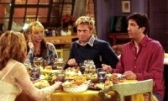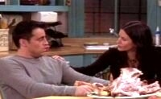
8.09 The One With The Rumor
Monica announces there will be no turkey for Thanksgiving because not enough people eat it;
Joey convinces her to make it anyway, and he'll finish it off.
Monica also invites an old friend from high school (Will), not knowing he hates Rachel for how she treated him.
Will reveals that in high school, he and Ross formed the "I hate Rachel Green Club," and spread a rumor that she was a hermaphrodite(n.阴阳人).
Rachel is quite upset until she's reminded that she spread the news that Ross made out with the 50-year old librarian.
Joey does eventually finish the turkey, then has some pie. [Scene: Joey and Rachel's, Joey is reading What to Expect When You’re Expecting as Rachel enters from her bedroom.]
What to Expect When You're Expecting/expect vi.(用进行时)怀孕 怀胎[eg:Mary is expecting]
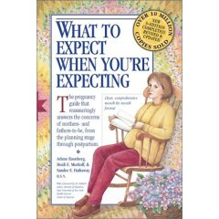
Joey: Hey Rach listen, did you know that during pregnancy your fingers swell up to twice their size and never go back.
swell up v.膨胀
Rachel: (looking at her fingers) Oh my…God! Let me see that! (Grabs the book from him.)
Joey: (laughing) You fall for it every time!
fall for v.To be deceived or swindled(v.诈骗) by[eg:He fell for the con(adj.欺诈的) artist's scheme and lost $200,000]
Phoebe: (entering) Hey!
Rachel: Hi!
Phoebe: I brought you my old maternity clothes! (Sets a bag on the counter.)
Rachel: Oh Pheebs that’s so sweet—(Grabs a pair of pants)—Ooh, those are so cute!
Phoebe: Yeah! And look, (Grabs the pants) see how they expand as the baby grows? (There’s a stretchy part in front.) And then after the baby’s born, they’re great for shoplifting melons.
stretchy adj.有弹性的/shoplift v.冒充顾客在商店内偷窃(商品)/melon n.瓜
Monica: (entering) Oh good you’re all here. Thanksgiving tomorrow, four o’clock. (To Rachel) Oh, guess who I invited. Remember that guy Will Colbert from high school?
Rachel: No.
Monica: He was in Ross’s class…marching band…kinda overweight? Well, really overweight. I mean I was his thin friend.
A marching band is a sporting group of instrumental musicians who generally perform outdoors, and who incorporate movement – usually some type of marching – with their musical performance. Instrumentation typically includes brass, woodwinds(n.木管乐器), and percussion instruments and the music usually incorporates a strong rhythmic(adj.节奏的) component suitable for marching. In addition to traditional parade performances, many bands also perform field shows at special events (often American football games) or at marching band competitions. Marching bands are generally categorized by function and by the style of field show (if any) they perform. Increasingly, Marching Bands are performing indoor concerts, in addition to any "Pep Band" duties, that implement many of the songs, traditions, and flair(n.本领) from outside performances.
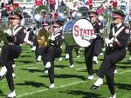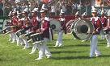
Rachel: Wow! I don’t remember him. Honey, are you sure you’re not talking about your imaginary boyfriend.
Monica: No that was Jarred! Wow! I haven’t thought about him in a long time… (Stares off into the distance lost in thought.) (Pause) Anyway, umm Will’s, Will’s here on business and he didn’t have a place to go so I invited him here.
on business adv.因公(出差)
Rachel: Oh that’s nice.
Monica: Oh, and by the way, he’s lost a bunch of weight. I mean he looks goo-ood! Okay, I mean really, really gorgeous! (Joey clears his throat.) I still love Chandler.
Joey: Wouldn't hurt you to say it once in a while.
once in a while adv.偶尔
Monica: All right okay, just so you know, I’m not gonna make a turkey this year.
Joey: What?!
Monica: Well Phoebe doesn’t eat turkey…
Joey: Phoebe!
Phoebe: Turkey’s are beautiful, intelligent animals!
Joey: No they’re not! They’re ugly and stupid and delicious! Plus, eating them is like a tradition. You know,it goes back to the first Thanksgiving when the Indians sat down with the cowboys.
Rachel: Oh, right. That's when they had that big rodeo at Plymouth Rock.
Plymouth Rock is the traditional site of disembarkation(n.登陆) of William Bradford and the Mayflower Pilgrims who founded Plymouth Colony, in what would become the United States. There is no contemporary reference to it, and it is not referred to in Bradford's journal Of Plymouth Plantation(n.种植园) or in Mourt's Relation. The first reference to the Pilgrims landing on a rock is found one hundred years after they landed in 1620. 普利茅斯石[五月花号渡过了科德角湾，在普利茅斯港抛下了锚链。移民们划着小艇登陆时，按照古老的航海传统，首先登上了一块高耸于海面上的大礁石。五月花号上礼炮轰鸣，人声鼎沸，共同庆祝新生活的开始。后来，这块礁石就被称为“普利茅斯石”，成为美洲新英格兰第一个永久性殖民地的历史见证]
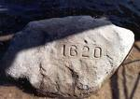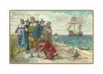
rodeo<美>牛仔竞技表演
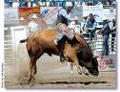
Monica: All right! Okay, it’s not just Phoebe. Will’s still on a diet, Chandler doesn’t eat Thanksgiving food, and Rachel’s having her aversion to poultry.
aversion n.厌恶/poultry n.家禽
Joey: She is?
Rachel: Did you remember I had to leave the room the other day when you had that roast chicken?
roast v.烤
roast chicken
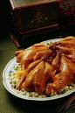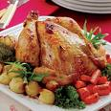
Joey: Yeah. But I thought that was because I put the whole thing on my hand and made it walk across the table.
Monica: Anyway, it just doesn’t seem worth it to make a whole turkey for just three people. Okay? It’s a lot of work.
Joey: But you gotta have turkey on Thanksgiving! I mean, Thanksgiving with no turkey is like-like Fourth of July with no apple pie! Or Friday with no two pizzas!
Fourth of July： An Independence Day is an annual celebration commemorating the anniversary of a nation's assumption(n.担任) of independent statehood, usually after ceasing to be a colony or part of another state. Most countries honour their respective independence day as a national holiday. n.美国国庆日（七月四日）

Monica: All right fine! If it means that much to you! But just—there’s gonna be a ton left over.
Joey: No there won’t! I promise I will finish that turkey!
Monica: All right, you’re telling me you can eat an entire turkey in just one sitting?
sitting n.(分批开饭的)一批
Joey: That’s right!‘Cause I’m a Tribbiani! (To Rachel) And this is what we do! I mean we may not be great thinkers or world leaders, we don’t read a lot or run very fast, but damnit! We can eat!
Opening Credits
[Scene: Monica and Chandler's, Chandler is watching football, and it’s actually the right game Green Bay at Detroit (although not this year’s), as Monica is getting everything ready.]
Green Bay钱德勒和菲比都不愿帮助莫尼卡干活，就一起坐在沙发上看“绿湾队(Green Bay)”的比赛，这是美国职业足球联盟的一支队伍，来自威斯康辛州(Wisconsin)由于名字里有“绿”字，环保主义者菲比就说这是她最喜欢的“湾”/The Green Bay Packers are a professional American football team based in Green Bay, Wisconsin. They are currently members of the North Division of the National Football Conference (NFC) in the National Football League (NFL).The Packers are the last remaining example of the "small town teams" that comprised a majority of the NFL during the 1920s. Green Bay is by far the smallest media market to be the home of a North American major professional sports league team (though their fanbase includes Milwaukee, and the rest of Wisconsin).Founded in 1919, the Packers joined the league in 1921. The team has actually been playing since 1896. Curly Lambeau began heading the team in 1919.Today, the team holds the record for most NFL league championships with 12: nine NFL Championships prior to the Super Bowl era; two additional titles in 1966 and 1967, after which they defeated the American Football League champion in Super Bowl I, Super Bowl II; and Super Bowl XXXI. The team also holds the distinction(n.声望 显赫) of winning the first two AFL-NFL Championship Games that were held before the AFL-NFL Merger, later referred to as Super Bowl I and II.The Packers are currently the only non-profit, community owned major league professional sports team in the United States. Currently, a total of 4,750,925 shares are owned by 111,967 stockholders — none of whom receive any dividend(n.红利).
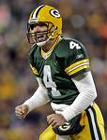
Announcer：Four wide receivers. On third and 18.
wide receiver n.列队在攻击线两端最外侧，或者是在攻击内锋旁而距离攻击线后1码以外的球员，叫做外接手。他们是四分卫在抛传进攻时的主要接球手。他们的体型多半较高瘦，但是由于有时也一样得替队友做阻挡，所以还是不能太过单薄/The wide receiver (WR) position in American and Canadian football is the pass-catching specialist. Wide receivers are among the fastest and most agile(adj.敏捷的) players in the game, and they are frequent highlight-reel favorites.
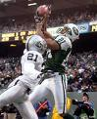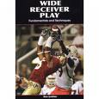
Monica: Hey, isn’t weird to think about how next year at this time they’ll be a little baby at the table? (Chandler turns around in horror.) (Seeing him) Rachel’s! But good to know where you’re at!
Phoebe: (entering) Hey!
Monica: Hey!
Phoebe: Happy Thanksgiving!
Monica: You too!
Phoebe: Anything I can do to help?
Monica: Actually there is. Chandler usually helps me with this, but he’s really into the game so I don’t want to bother him. Could you help me fold these napkins? (Hands her a stack of them.) 00:04:13
Phoebe: Sure!
Monica: I’m gonna go across the hall to check on the yams.
check on v.检查/yam n.山药
Phoebe: Okay. (She starts folding the napkins in half.)
Monica: No! No! No! No sweetie! No! Not like that! We’re not at a barn dance. You’ve gotta—you wanna fold them like swans. Like I showed you at Christmas time, remember?
barn dance n.谷仓舞/swan n.天鹅
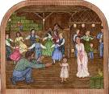
Phoebe: Yeah, it all just came screaming back to me. (Monica exits.) (To Chandler) So how’s the game?
Chandler: I have no idea.
Phoebe: What?
Chandler: Yeah! I’m just pretending to watch the game so I don’t have to help out with stuff.
Phoebe: I don’t believe you! That is…brilliant! And Monica has no idea?
Chandler: Nope! Every once and a while I just scream stuff at the TV.
(Monica enters and Chandler screams stuff at the TV.)
Monica: Is your team winning hon?
hon n.爱人
Chandler: Yeah! Anderson just scored again! (To Phoebe) There’s no Anderson.
Phoebe: Well I want to get in on this. Hey Mon? I don’t think I can help you after all, I didn’t realize this game was on.
get in on v.<口>参加 加入/after all adv.Everything else having been considered; ultimately[eg: A car is after all a means of transportation]
Monica: Oh, I didn’t know you liked football.
Phoebe: Well normally I don’t, but y’know…(looks at the TV)…Green Bay is playing.
Monica: You like Green Bay?
Phoebe: Well it’s only like my favorite bay! {Actually, it’s not bad. It just gets a little cold in winter, but in Wisconsin winter only lasts from August to June. J }
(Phoebe joins Chandler on the couch as there is a knock on the door which Monica answers.)
Monica: Hey!
Will: Hey!
(Oh, I should point out that the live studio audience at this point goes absolutely wild. And I had absolutely no idea that this Will character was that popular! Maybe they should make him the seventh friend. Which would work out just fine since he’s already married to one of them. Will is played by some guy named Brad Pitt, I guess he’s some sort of actor.)
at this point adv.此时此刻/ William Bradley "Brad" Pitt (born December 18, 1963) is an Academy Award-nominated American actor. In recent years, his relationships to Jennifer Aniston and Angelina Jolie, and his adoption(n.收养) of the latter's children have received significant press attention.

Will: Happy Thanksgiving!
Monica: Aww thanks! God Will I’m so glad that you came! You look great! You must’ve lost like…
Will: 150 pounds. Yeah, I’m gonna be in one of those Subway sandwich commercials.
Subway sandwich:莫尼卡邀请中学好友威尔来家一起过节，威尔也曾经和莫尼卡一样胖，但最终减肥成功，还被邀请去拍“赛百味三明治(Subway sandwich)”的广告。这是美国一家快餐店，据说幕后老板是大导演斯皮尔伯格，在全球已有一万个店面/Subway is the name of a multinational restaurant franchise that mainly sells sandwiches and salads. It was founded in 1965 by Fred De Luca and Peter Buck. The corporate name of Subway is Doctor's Associates, Inc. (DAI). The company has 26,793 franchised units in 85 countries as of November 21, 2006 and is the fastest growing franchise in the world. This rapidly growing chain added over 2,000 locations in 2005.
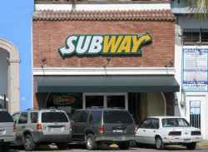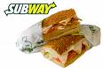
Monica: A pie! (Will brought a pie.)
Will: Oh right. All right, it’s no fat, it’s no sugar, it’s no dairy…it’s no good. Throw it out.
dairy n.奶油
Monica: You wanna meet some people? This is uh; this is my husband Chandler. Chandler, this is Will.
Will: Hey.
Chandler: Oh hey. I’d shake your hand but uh; I’m really into the game. Plus, I think it’d be better for my ego if we didn’t stand right next to each other.
Monica: This is Phoebe.
Phoebe: (nonchalantly glancing) Hey. (Turns back around.) Wow! (Looks up.) Well done.
nonchalantly adv.漠不关心地 冷淡地
Monica: (to Will) Wanna give me a hand?
Will: Sure! Monica, I can’t get over how great you look! You look stunning!
Monica: Well you look incredible too! You’re just—you’re so fit!
fit adj.健康的 强健的[eg: You look very fit, Mike]
Chandler: I’m watching the game, but I’m not deaf!
Monica: Oh umm, I meant to tell you, Ross is coming.
Will: Ross is coming. Great! I love Ross!
Monica: Good. And Rachel Green too. (Will stops suddenly.)
Will: Oh.
Monica: Is there a problem?
Will: Nope. Uh, it’s okay. It’s just uh, God I hated her.
Monica: What?
Will: Yeah, I hated her. She was horrible to me in high school. But hey, it was a long time ago, I’m in a good place, it might be actually fun to see her again. You got any cakes or cookies or something? (Starts looking.) No Will no!
Chandler: (To Phoebe) Y’know, it’s been a while since we’ve screamed something. Maybe we should.
Phoebe: Oh okay.
Chandler: Oh come on!
Phoebe: Noooo!! Damn you ref! You burn in hell!!!
ref n.裁判员
(Joey enters eating potato chips.)
Monica: Hey, what are you doing? You gotta save room, you’ve got almost an entire turkey to eat.
Joey: Let me explain to you how the human body works. I have to warm up my stomach first. Eatin’chips is like stretching.
stretching n.拉伸运动
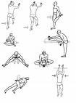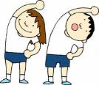
Monica: All right.
Joey: Don’t worry, Tribbianis never get full.
Will: I actually know what you’re talking about. I’m here to tell you something my friend, you can eat and eat and eat but nothing will ever fill that void.
Joey: (To Monica) Who the hell is this guy?
Monica: Will! From high school.
Joey: Oh hey!
Monica: (to Will) Joey.
Will: Hello.(refuses to get some chips)
Ross: (entering) Will!
Will: Ross!
Ross: Hey-hey you came! Man you look incredible! Hot stuff! (They hug and Ross realizes what he said.) Hot stuff?
Will: It’s good to see you man.
Ross: Yeah, you too. Man, so-so what are you up to?
Will: I’m a commodities broker.
commodity broker n.货物买卖经纪人
Ross: Really? Yeah that-that sounds interesting.
Will: Yeah, it’s not. But I’m rich and thin.
Ross: Oh! Man I don’t think I’ve seen you since uh, Lance Davis’graduation party.
Will: That was such a fun night!
Ross: Yeah. It would’ve been good if we had gotten in, but still real fun.
Will: Yeah.
Ross: Yeah.
Will: God we were lame back then. Do you remember how into dinosaurs we were?
lame<俚>plain stupid 烂
Ross: (laughs) Yeah.
Will: So what do you, what do you do now?
Ross: So how long are you in town?
Rachel: (entering, carrying a baking dish) Hi!
baking dish n.烤盆
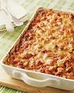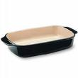
Monica: Hey sweetie. Oh good. (Takes the baking dish from her.)
Will: (glaring at Rachel) Rachel Green.
Ross: Aw—oh, that’s right. Are-are you gonna be okay?
Will: Oh, I’ll-I’ll be fine. Just God I hate her Ross! I hate her!
Ross: Will, high school was-was a long time ago.
Will: Look at her standing there with those yams! My two greatest enemies Ross: Rachel Green and complex carbohydrates.
carbo-hydrate n.<化>碳水化合物
Rachel: (sees Will) Oh my God Monica, who is that?
Monica: That’s Will from high school!
Rachel: Oh! I do not remember him! Wow! He's really got that sexy, smoldering thing going on. (We see Will angrily staring at Rachel.) Oh my God, he’s… Look at the way he’s just staring at me. I think he’s trying to mouth something to me, but I can’t make it out. (Will mouths, "I hate you.")
smolder v.闷烧/smoldering<俚>used to describe someone who is strikingly attractive because of fiery(adj.炽热的), bold, and strong characteristics.
Monica: Okay, dinner’s ready!
Chandler: Good game!
Phoebe: Yeah.
Chandler: Yeah. Solid effort. Solid effort.
solid <俚> great; fantastic; pro (表演)精彩的[eg:that was a solid effort]
Monica: Oh, so who won?
Phoebe: (simultaneously) Green Bay.
Chandler: (simultaneously) Detroit.
Monica: What?
Phoebe: Well the Lions technically won, but it was a moral victory for the Green Bay…Mermen.
moral victory n.精神胜利/merman n.(传说中的)雄人鱼 善泳的男子
merman
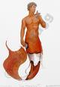
(They sit down at the table and Will goes to talk to Rachel.)
Rachel: Hi! Will, right?
Will: Right.
Rachel: Hi! I’m Rachel Green.
Will: Oh I-I remember you.
Rachel: Really?! Aren’t you sweet! I gotta tell you though, I am, I am having the hardest time placing you. Oh-oh hang on! Did we umm, did we fool around at Lance Davis’ graduation party?
place vt.(常用在疑问句 否定句中)看清 想起[eg:I remember her name but can't place her face]/hang on v.等着
Will: You are unbelievable.
Rachel: Thank you!
Monica: (breaking it up) Uh Rachel? Rachel, why don’t you sit here? (Next to Joey) And Will you sit way over there. (The other side of the table.)
(Monica sets something on the table and removes the cover. It kinda looks like turkey.)
Joey: That’s it?! Even if nobody helps me I can eat that no problem. At least give me a challenge!
Monica: (laughs) This is Chandler’s chicken. This is the turkey. (Sets down a huge turkey.)
Joey: (quietly) Oh. How-how big is that?
Monica: About nineteen pounds.
Joey: (To Rachel) It’s like me when I was born.
Rachel: All right, who would uh, like some yams? Will?
Will: Oh, you’d like that wouldn’t ya?
Rachel: What? (Joey starts offering Ross some turkey.) Oh y’know what? Can we please keep the chicken and the turkey and everything on the other side of the table? The smell is just yuck!
Will: (sneeze talks) Typical.
Rachel: I’m sorry. What?
Will: I said it was typical. Typical of you, Rachel Green, Queen Rachel does whatever she wants in little Rachel land. (Does a fake hair flip.)
Joey: (To Monica) Seriously, who is this guy?
Rachel: Umm, I’m sorry. Do you-do you have a problem with me?
Will: I don’t know? Do I? Do I?
Phoebe: I think you do.
Monica: (To Rachel) Apparently you were umm, a little mean to him in high school.
Will: A little mean? You made my life miserable!
miserable adj.痛苦的
Rachel: I’m-I’m—I had no idea. I’m sorry. I…
Will: Well you should be. Screw it! Bring on the yams!
screw it<俚>Fuck it
Monica: Oh Will. But you-you’ve worked so hard…
Will: Yams!!!!
Monica: Okay. (Chandler grabs the dish from Monica and hands it to Will who starts dishing out a large helping.)
dish out v. 盛于盘中/helping n.(食物)一份
Rachel: Uh Will umm, I just want to say that I’m real sorry for whatever I-I did to you in high school…
Will: Oh, it wasn’t just me. We had a club!
Rachel: You had a club?!
Will: That’s right, The I Hate Rachel Green Club!
Rachel: Whoa! My God! So what, you all just joined together to hate me?! Who else was in this club?
Will: Me and Ross. (Points at Ross.)
Ross: No need to point, she knows who Ross is.
Commercial Break
[Scene: Monica and Chandler's, scene continued from earlier.]
Rachel: (To Ross) So you were in an I Hate Rachel club?
Will: Yes he was. (Holds up his hand for a high-five.)
Ross: No. No.
Rachel: So who else was in this club?
Ross: Uh actually, there-there was also that exchange student from Thailand but I-I don’t think he-he knew what it was.
exchange student n.交换留学生
Chandler：You guys were cool.
Rachel: So Ross, we went out for two years, and you never told me you were in an I Hate Rachel club.
Will: You went out with her?! We had a pact!
pact n.协定
Ross: That was in high school! It’s not like it was binding forever.
Will: Then why did it have the word eternity in it?
eternity n.永远 不朽
Joey：I'm thinking of joining an 'I Hate Turkey Club.'Although, I do Iove a turkey club.
turkey club
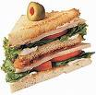
Rachel: Okay Monica, did you know about this?!
Monica: I swear I didn’t. (To Ross and Will) Hey! Is that why you guys used to go up to your bedroom and lock the door?
Ross and Will: Yeah.
Monica: Hmm, a little relieved, I gotta say.
Ross: Look Rach I-I’m sorry, okay? I…I was a stupid kid, okay? The only reason I joined…
Will: Co-founded!
cofound v.共同建立
Ross: …co-founded. Co-founded the club was that I was insanely in love with you. Obviously I didn’t handle it very well. But if you think about it the I Hate Rachel Club was really the I Love Rachel Club.
Will: Uh, except that it was really the I Hate Rachel Club.
except that adv.只可惜
Rachel: Okay. So what? You guys would just like get together and like just say mean things about me?
Will: Well, we did a little more than that.
Ross: No-no! No-no. No-no.
Phoebe: What?! What else did you do?
Will: We started a rumor.
Rachel: What rumor?
Phoebe: Oh, come on Will! Just take off your shirt and tell us!
Rachel: Ross!
Ross: It was no big deal. We-we…said that the rumor was…that umm…you had both…male and female reproductive parts.
reproductive adj.生殖的
Rachel: What?!
Will: That’s right! We said your parents flipped a coin, decided to raise you as a girl, but you still had a hint of a penis.
hint n.少许 微量(+of)[eg: There was just a hint of pepper in the soup]
Rachel: (shocked) Oh my God!
Monica: You started that?!
Rachel: What?! You heard that?! (Goes and stands behind Joey.)
Monica: Everyone at our school heard it!
Chandler: Everybody at my school heard it! You were the hermaphrodite cheerleader from Long Island?!
hermaphrodite adj.雌雄同体的
Rachel: Oh no!!!! Oh my God!! This is all making so much sense to me now! This is why Adam Carter wouldn’t go out with me! This is why Billy Tratt would just stay in this region! (Motions to her breasts.) (Joey has turned around.)
Ross: Actually, Billy Tratt is gay now. So-so that one’s not really our fault.
Rachel: Monica, how come you never told me this?!
Monica: I thought it might be true. And I was afraid that you were gonna cry and then show it to me.
(Joey is now looking at Rachel, and since Rachel’s standing and he’s sitting down and he’s not looking at her face… You get the picture.)
Rachel: Joey stop staring! There’s nothing there! It’s not true!
Joey: I’m afraid I’m gonna need proof. Come on, whip it out.
whip it out <口>突然喊出 突然拿出
Rachel: Oh! (Hits him and storms out.)
[Time Lapse, dinner has ended for everyone except Joey who looks like to have finished the turkey, until he turns the plate around and reveals he only ate one side.]
Joey: You are my Everest.
Everest n.珠穆朗玛峰(世界最高峰)
Monica: Joey, you don’t have to finish that.
Joey: Oh yes I do. Otherwise what’s next? Today I’m just a guy who can’t finish a turkey, but tomorrow I’m the guy who eats half a Powerbar, wraps up the rest, and puts in the fridge? No! No, I just…I just—I gotta change my pants. (Gets up and heads for the door.) What was I thinking? Jeans have no give. (Exits.)
wrap up v.包起来/give n.弹性/PowerBar is an American maker of energy bars and related products (particularly sports drinks and gel-based footstuffs for distance athletes).The PowerBar company was founded by Brian Maxwell a Canadian athlete and entrepreneur in his kitchen with $55,000 in cash. The company was launched in 1986 in Berkeley, California, and eventually acquired a headquarters building in downtown Berkeley.The company eventually earned $150 million in sales before being purchased by Nestlé in 2000 for $375 million.
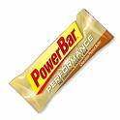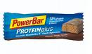
Monica: Guys, help me with the dishes. There's a lot of pots and pans.
pots and pans n.炊事用具 锅碗瓢盆
Chandler: Honey, I'd Iove to, but the second game is about to start.
Phoebe：Oh, yeah, the second game. More football for the Pheebster.
Monica: Who's pIaying?
Chandler: Los Angeles.
Monica: Last time I checked, Los Angeles didn't have a football team.
Chandler: Did I say Los Angeles? I meant the team that used to be in Los Angeles and is now in St. Louis. I actually knew that.
The City of St. Louis, is an independent city completly surrounded by St. Louis county on the west, and the Mississippi river on the east, in the U.S. state of Missouri. Sometimes written Saint Louis the city, named after Louis IX of France, is adjacent to but not part of St. Louis County, Missouri, thus giving it an almost-unique situation similar to Baltimore, Maryland in comparison to other metropolitan areas. This separation between the city of St. Louis and St. Louis County skews(v.歪曲) the statistics, especially when St. Louis news events are reported in the media.

Monica: Okay, quick, name three players on that team.
Chandler: Gretzky....Agassi....I'm a pretty little girl.
Wayne Douglas Gretzky, OC (born January 26, 1961) is a retired Canadian professional ice hockey player who is currently part-owner(n.共有人 合伙人) and head coach of the Phoenix Coyotes. Born in Brantford, Ontario and nicknamed "The Great One," Total Hockey: The Official Encyclopedia of the NHL calls Gretzky "the greatest player of all time". He is generally regarded as the best player of his era and has been called "the greatest hockey player ever" by many sportswriters, players, coaches, and fans. Along with his many awards and achievements, he is the only player to ever have his playing number, 99, officially retired across the entire National Hockey League. Identified as a hockey prodigy at a very young age, Gretzky regularly played at a level far above his peers. He became a full professional at the age of 17 in the World Hockey Association, leading to a long career in the NHL. He set 40 regular-season records, 15 playoff records, 6 All-Star records, won four Stanley Cups with the Edmonton Oilers, and won 9 MVP awards and 10 scoring titles. He is the only player ever to total over 200 points in a season (a feat that he accomplished four times in his career). In addition, he tallied(v.得分) over 100 points a season for 15 NHL seasons, 13 of them consecutively(adv.连续地). He retired from playing in 1999, becoming Executive Director for the Canadian national men's hockey team during the 2002 Winter Olympics. He also became part owner of the Phoenix Coyotes in 2000 and following the 2004-05 NHL lockout[n. 停工(业主为抵制工人的要求而停工)] became their head coach.

Andre Kirk Agassi (born April 29 1970, in Las Vegas, Nevada) is a former World No. 1 professional tennis player from the United States. He is one of only five male players to have won all four Grand Slam singles events during his career. He is the only player in the open era(n.在一个公开赛赛季) to have won every Grand Slam singles title, to have won the Tennis Masters Cup, to have been part of a winning Davis Cup team, and to have won an Olympic gold medal. He has won 17 ATP Masters Series tournaments, more than any other player. He is generally considered to be one of the greatest tennis players of all time. Because of sciatica(<医>坐骨神经痛) caused by two bulging(adj.肿胀的) discs(<解>盘 片) in his back, a Spondylolisthesis (shifting vertebrae[n.椎骨]), and a bone spur that interferes with the nerve, Agassi retired from professional tennis on September 3, 2006, after losing in the third round of the US Open. Agassi is married to Steffi Graf and has two children. He is the founder of the Andre Agassi Charitable Foundation, which has raised over $70 million for at-risk children in Southern Nevada.In 2001, the Foundation opened the Andre Agassi College Preparatory Academy in Las Vegas, a K-12 public charter school for at-risk children.
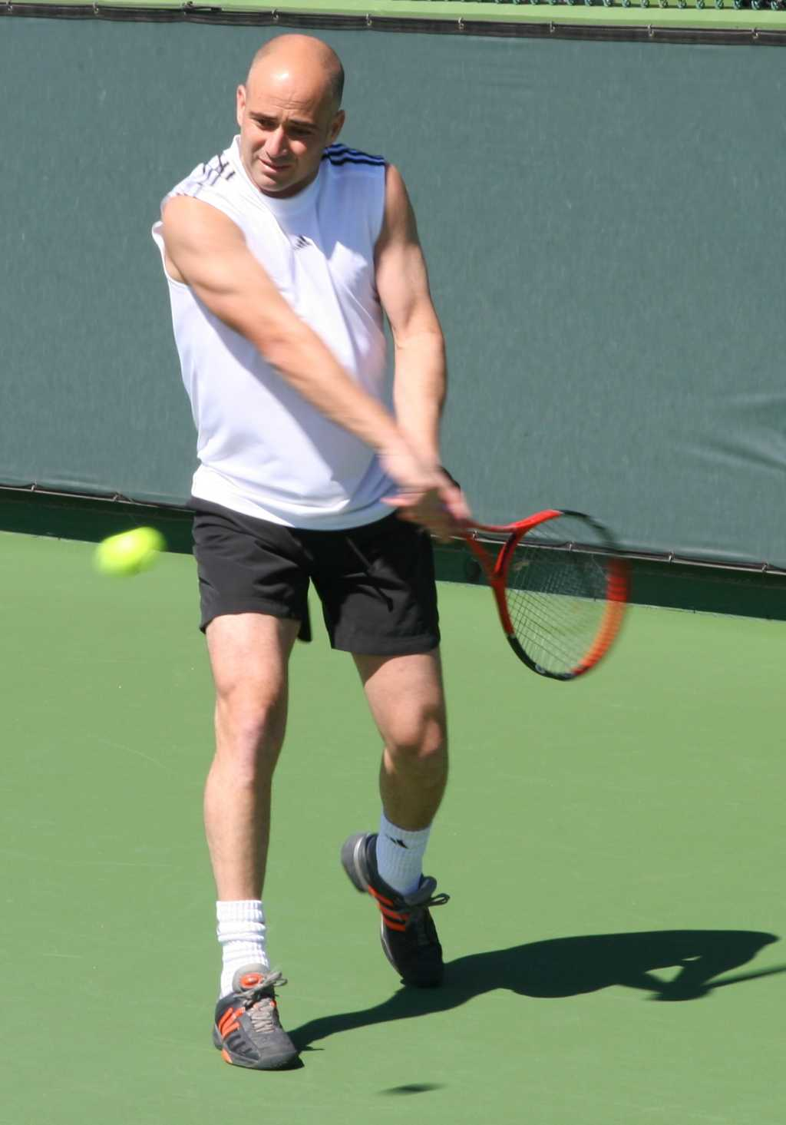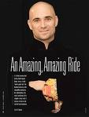
Rachel: (entering carrying a book) Okay! Okay! Listen to what Sean McMahon wrote in my yearbook senior year, "Dear Rach, you’re such a good person." Not girl! Person!
Ross: Rach, I think you’re reading a little too much into it.
Rachel: (reading what he wrote again) "Dear Rach, you’re a great person. Sorry about your teeny-weenie." (Will laughs.)
teeny-weenie<俚>小鸡鸡
Ross: Look, what do you want me to do? Do you want me to call everyone in the entire school and tell them it wasn’t true?!
Rachel: Yes!
Will: Could you also tell them I’m skinny now?
Monica: Oh! Me too!
Ross: Well look-look I’m not calling anybody! Okay? It was like a million years ago!
Rachel: I don’t care how long ago it was! You told people that I was half and half! Y’know what? I just want to point out I never did anything to hurt you in high school.
Monica: That’s not totally true.
Rachel: What?
Ross: What?
Monica: Well you-you did start that rumor about Ross making out with Mrs. Altman, our 50-year-old librarian.
Ross: (shocked) (To Rachel) How did you know that?!!!!
Monica: It’s true?!!
Ross: No.
Rachel: Yes it is! I saw you guys going at it behind the card catalog!
go at v.尽全力干/card catalog n.(图书馆专用的)卡片目录
card catalog
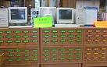
(Ross is at a loss for words.)
Ross: Hey, what were you doing in the library?
Rachel: They had magazines.
Will: Mrs. Altman? She also made out with Takaka Ci-Kek the night before he went back to Thailand.
Chandler: I’m sorry. When you were in high school you made out with a 50-year-old woman?
Ross: Hey! She didn’t look 50!
Chandler: Did she look 16?
Rachel: Ohh, there’s a picture of her in the yearbook actually.
Phoebe: Oh! (They all look.) Wow!
Ross: She didn’t photograph well!
photograph well v.照起相来显得自然好看 上照
Chandler: Well, she probably wasn’t familiar with the process having spent most of her life sitting for oil paintings!
sit for v.坐着(让人画像或照相)
Phoebe: So how did this happen? Did she, did she lure you to an early bird dinner?
an early bird n.早到者
Ross: I was working late in the library one afternoon. It was just the two of us. She needed some help with her word jumble. And one thing led to another. If you must know, Anita was very gentle and tender. May she rest in peace…
word jumble n.将字母顺序搞乱后 再拼写正确/May she rest in peace 愿她安息
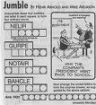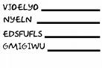
Monica: Didn’t she walk with a cane?
cane n.手杖 拐杖[eg: Grandpa takes along a cane when he goes out for a walk]
Ross: Only when it was damp!! (To Rachel) I can’t believe you-you told people about this?! Everybody knew?! Y’know what? (To Will) I’m back in the club!
damp adj.潮湿的
Will: Yeah! (They high-five.) Shall I call the meeting to order?
Ross: Is everybody present?
Will: With the exception of Ta-Taka.
with the exception of adv.除...以外
Phoebe: I wanna join!
Rachel: Wh—Phoebe!!
Phoebe: I’m sorry. I’m sorry. I never got to be in a club. I-I didn’t go to high school, but three of us would meet behind a dumpster to learn French. Bonjour.
dumpster n.<美>垃圾桶/bonjour<法>你好
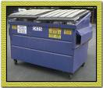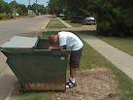
Rachel: All right, y’know—Fine! You guys have your stupid little club, but I would just like to say is what you did to me is way worse than what I did to you! You gave me a teeny-weenie! (Will laughs.)
Monica: All right, listen you’re just being silly. Rachel, even with that rumor you were one of the most popular girls in school and everyone wanted to be like you. One girl wanted to be like you so much she stuffed her pants with a Tootsie Roll!
Tootsie Rolls are a chocolatey chew candy that have been manufactured in the United States for over 100 years. The cylindrical(adj.圆柱的) cocoa-flavored candies come individually wrapped in a slip of brown paper, and are a well known piece of Americana(n.有关美国的史料). They are one of the best selling candies in America and throughout the world today.
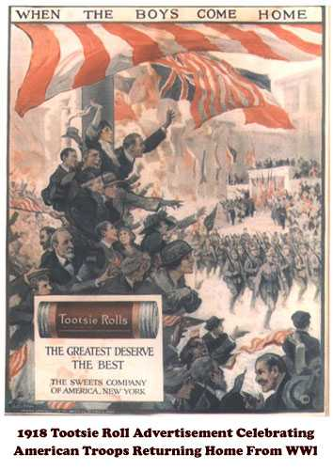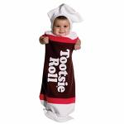
Rachel: Wow…
Monica: And Ross, if it weren’t for Rachel’s rumor I mean no one in high school would even know who you were. She put you on the map!
put sb ont the map:把某人搬上了地图,就是使大家开始了解这个人,知道这个人.比如说一个人写了一个报告,非常独到,因此在行业里他被人所知道了.就说"That report put him on the map"
Ross: As a romancer of the elderly.
Monica: Hey! Mrs. Altman was the kind of woman you could tell she used to be pretty.
Ross: The eyes…did still sparkle.
sparkle v.(眼神)发光
Monica: Hey guys this stuff is just so way in the past. You-you’ve been through so much since then. And right now you’ve got so much more important stuff going on in your life. Can’t you just let this go?
Rachel: She’s right.
Ross: Yeah. I mean we are having a baby together.
Will: Hold on! You got her pregnant?
Ross: Yeah.
Will: Are ya getting married?
Ross: Nope.
Will: So you knocked her up but you’re not gonna marry her. Dude! (Wants another high-five and Ross ignores him.) Anybody?
Phoebe: Okay. (Goes over and hugs him.) It’s exactly how I’d imagined it would be.
Joey: (entering, wearing the maternity pants from earlier) All right where’s that turkey!
Phoebe: Joey! Those are my maternity pants!
Joey: Not now! These are my Thanksgiving pants!
Closing Credits
[Scene: Monica and Chandler's, Will has left and the rest of the gang is watching Joey finish the turkey.]
Joey: Well that’s it. I’m done. Whew! (Wipes his forehead.) There come the meat sweats. (Chandler hands him a towel and he wipes his face.)
Monica: Well Joey, we’re all…we’re all very proud of you.
Chandler: Yes, I believe we can expect a call from the President any moment now.
Phoebe: Is there anything we can do for you?
Joey: No just, nobody press on my stomach.
Rachel: You can keep those pants by the way.
(Joey notices Monica has gotten a pie.)
Joey: Whoa—hey—wh-wh-what do you got there? What is that? Pie?
Monica: Yeah, you want some?
Joey: Ah, just cut me a little sliver. (Monica prepares to cut a little sliver.) A little bigger. (Monica prepares to cut a bigger piece.) Little bigger. (Monica moves the knife again.) What?! Are you afraid you’re gonna run out?! Cut me a real piece!
sliver n.小片 长条
End

